**Practical 4**

**Name:** Ishaan Bose

**Reg. no:** 2147116

**1) Why the Auto Scaling feature is significant in cloud computing?**

Autoscaling provides users with an automated approach to increase or decrease the compute, memory or networking resources they have allocated, as traffic spikes and use patterns demand. Without autoscaling, resources are locked into a particular configuration that provides a preset value for memory, CPU and networking that does not expand as demand grows and does not contract when there is less demand.

Autoscaling is a critical aspect of modern cloud computing deployments. The core idea behind cloud computing is to enable users to only pay for what they need, which is achieved in part with elastic resources -- applications and infrastructure that can be called on as needed to meet demand.

**2) Describe the following**

**1. Metric-based autoscaling**

**2. Schedule-based autoscaling**

1. An autoscaling action is triggered when a performance metric meets or exceeds a threshold.
2. Autoscaling events take place at the specific times that you schedule.

**3) Demonstrate Metric based autoscaling or Schedule based auto scaling to cater your organizations business requirements. (Specify the requirements)**

1. Go to your instances and select the desired instance.
2. Click on actions and then Instance settings -> Attach to Auto Scaling Group

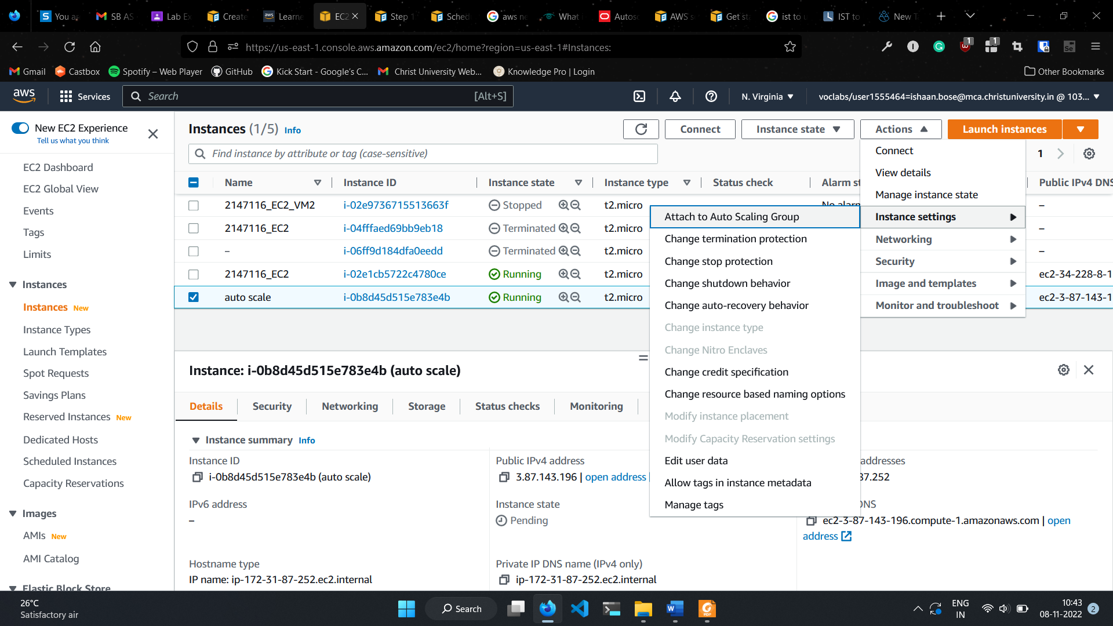

1. Give a name to the auto scaling group and click attach

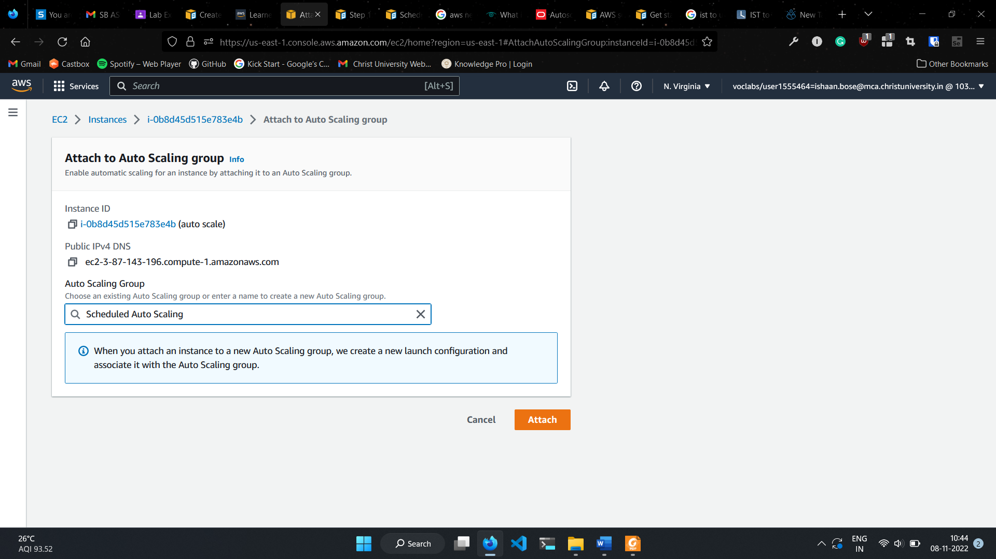

1. Scroll to Auto Scaling in the Navigation Panel and select Auto Scaling Groups under Auto Scaling

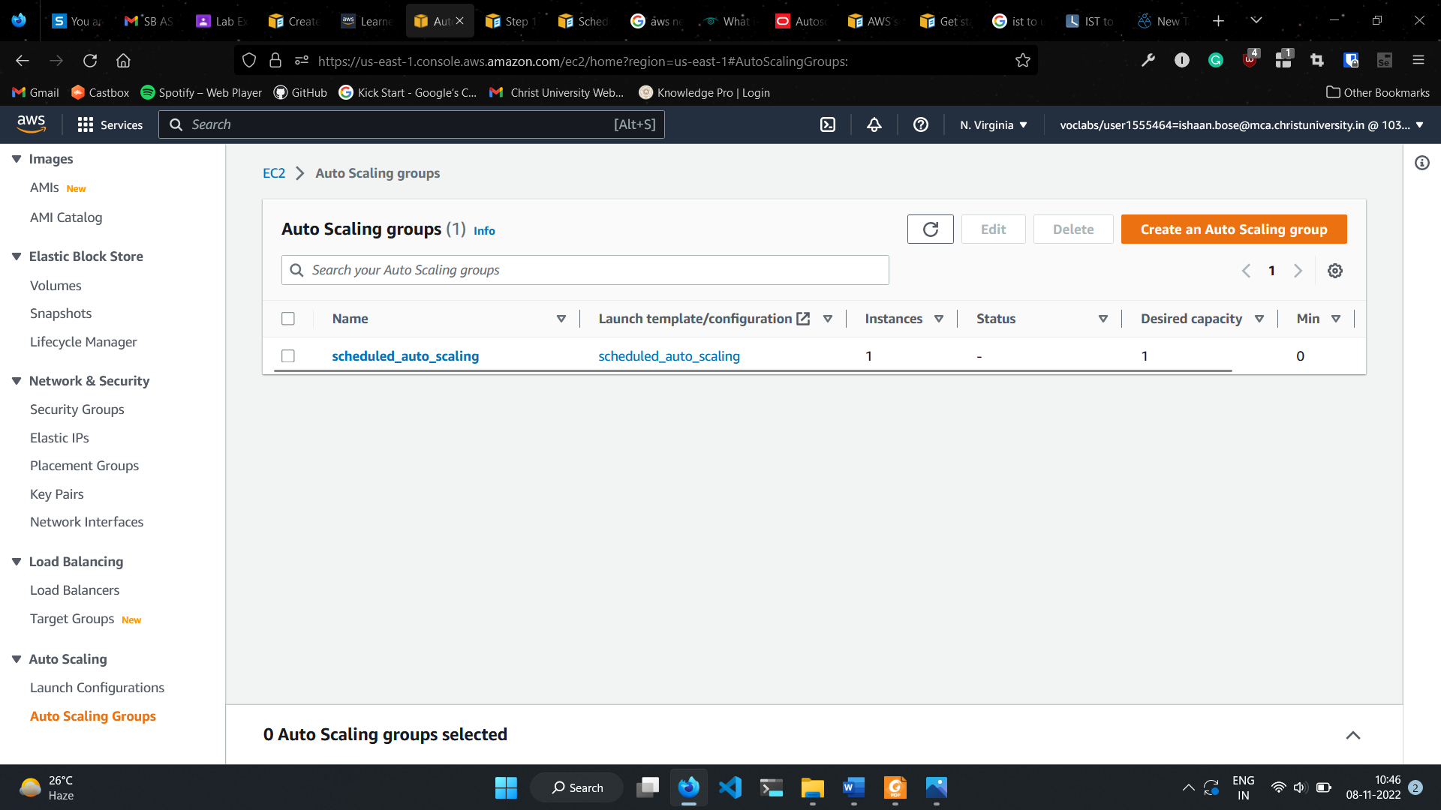

1. Select the created auto scaling group, go to automatic scaling and scroll down to scheduled actions.

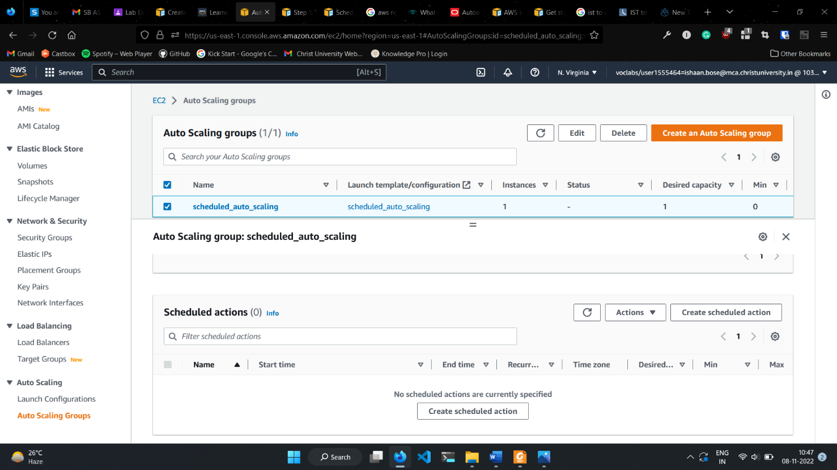

1. Click on create scheduled action.
2. Provide a suitable name, enter desired, minimum, and maximum capacity according to your needs
3. Select the desired time zone and select the desired date and time.

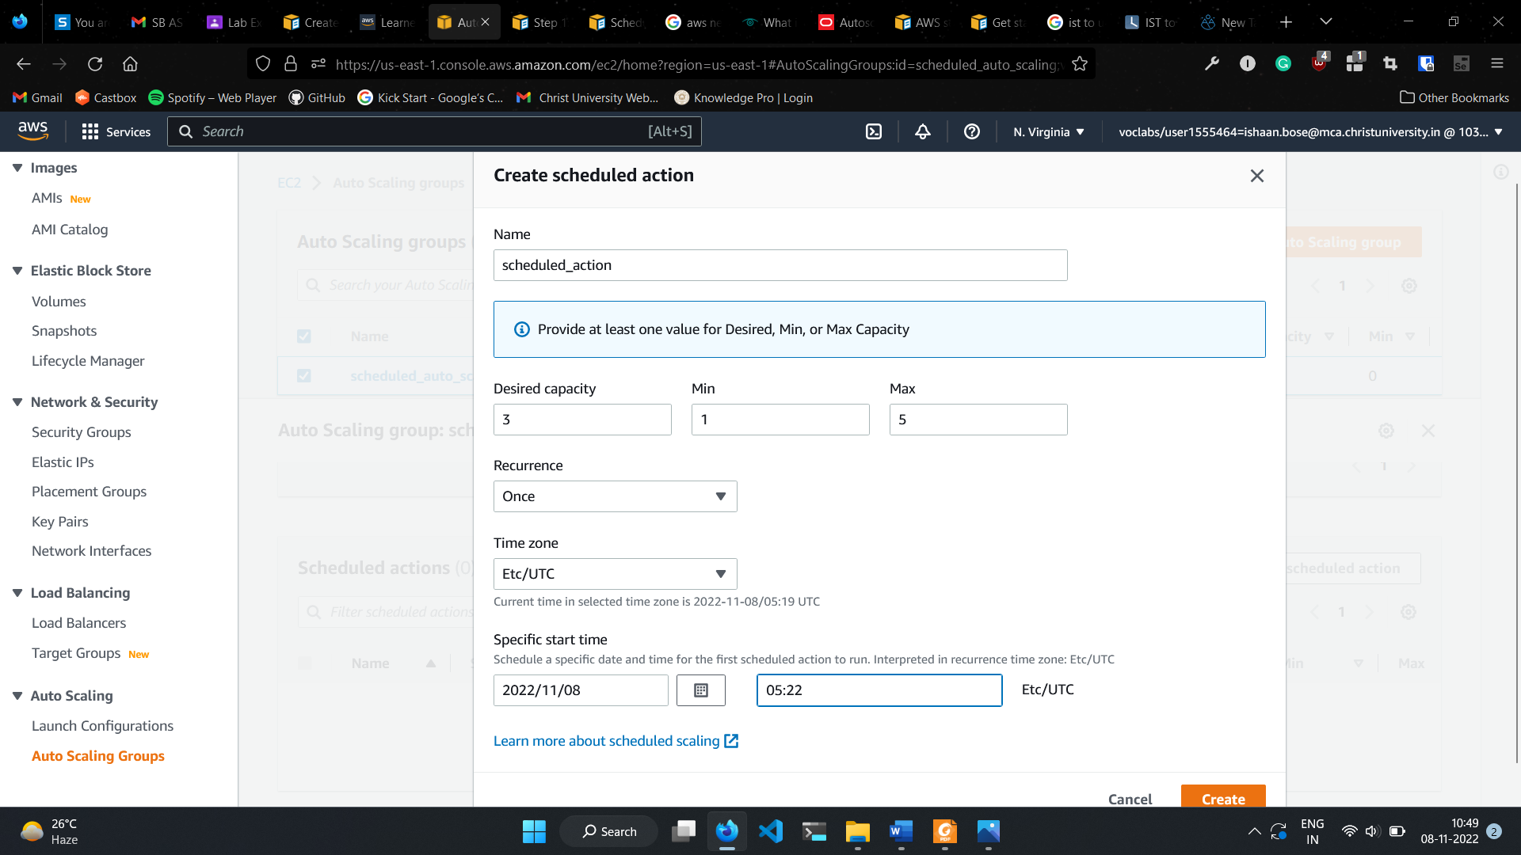

1. Click create.

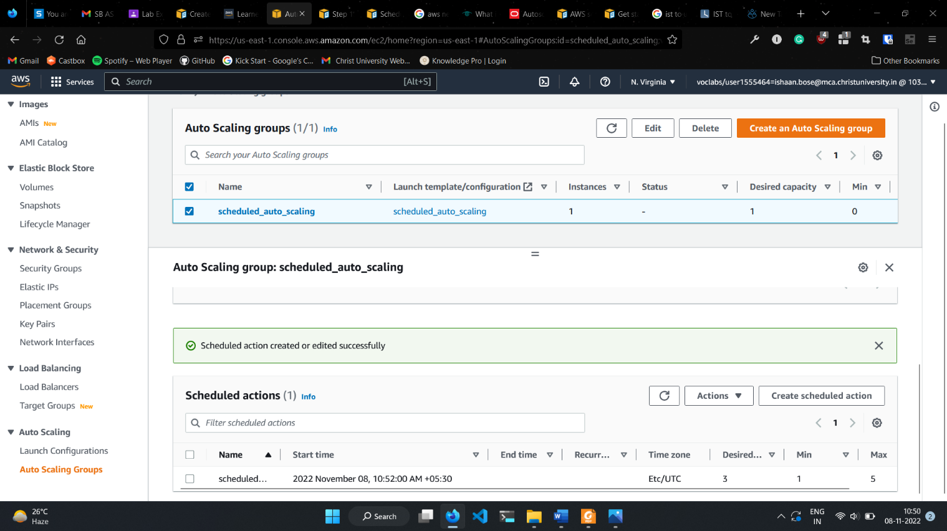

1. Once the selected time has passed, go back and view all instances.
2. New instances should be created.

